SMTP SERVER WITH EMAIL STORAGE AND MANAGEMENT FEATURES

Submitted By

Project Leader: Talha Munir Saeed
Project Leader Roll Number: 22K-4465

Department of Computer Science
National University of Computer & Emerging Sciences

1. Motivation
The motivation behind developing a custom SMTP server with storage capabilities stems from the need to understand email protocols at a fundamental level while creating a practical solution for email management and storage. Traditional SMTP servers primarily focus on sending emails, but our implementation addresses the gap by providing comprehensive email handling, including reception, storage, and management functionality. This project demonstrates the practical application of network protocols and database management in creating a full-featured email system.

2. Overview
Our project presents a comprehensive email client application that revolutionizes email management by combining user-friendly interface design with powerful backend functionality. This system addresses the limitations of traditional email solutions by providing a unified platform for both sending and receiving emails while maintaining complete control over data storage and organization with different providers.
The application serves as a bridge between standard email protocols (SMTP and IMAP) and modern user expectations for email management. Users can seamlessly compose, send, receive, and organize emails while benefiting from advanced features such as code syntax highlighting, intelligent attachment handling, and persistent email history storage. The system supports multiple email providers including Gmail, Yahoo, and Outlook, making it versatile for various user needs.
At its core, the project demonstrates the practical implementation of network protocols, database management, and graphical user interface development. It provides students and developers with insights into how popular email clients work while offering the flexibility to customize and extend functionality as needed.

2.1 Significance of the Project
The email client implementation project provides hands-on experience with network protocols, GUI development, and database management. It challenges students to understand email communication at both protocol and application levels, combining SMTP/IMAP protocols with modern user interface design.The project's significance is amplified by its unique features like Intelligent code detection, Advanced email management, Multi-provider support, Real-time email processing
The project has practical applications in enterprise environments requiring custom email handling, educational value in demonstrating protocol implementation, and serves as a foundation for understanding modern email client architecture. Its focus on code file handling makes it particularly relevant for developer communities and academic environments.

2.2 Description of the Project
Our project implements a complete email client application with both graphical user interface (GUI) and backend functionality for handling email operations. Unlike traditional SMTP servers that only handle sending we also went along and implemented IMAP for receiving, our system provides a comprehensive solution for:
- Email Sending: Using SMTP protocol with features like HTML support, attachments, and syntax highlighting
- Email Receiving: Using IMAP protocol for fetching and organizing emails
- Email Storage: MySQL database integration for persistent storage of sent and received emails
- User Interface: Tkinter-based GUI for easy interaction with the email system
The project addresses the need for a custom email client that provides full control over email management while understanding the underlying protocols. It demonstrates practical implementation of network protocols, database management, and GUI development.

2.3 Background of the Project
A review of background material that we found
- RFC 5321: Simple Mail Transfer Protocol [1]
- RFC 5322: Internet Message Format [2]
- RFC 3501: Internet Message Access Protocol - Version 4rev1 [3]
- SMTP specification documentation
- IMAP protocol specifications
- Python socket programming documentation [4]
- Python threading and queue documentation [5]
- MySQL connector/Python documentation [6]
- Tkinter GUI programming guide [7]
- Email attachment handling best practices [8]
- SSL/TLS encryption standards for email protocols
Note: While online video tutorials were referenced during development for practical implementation guidance, this report focuses on official documentation and technical standards as primary sources.

2.4 Project Category
This project falls under the Research-based Product category as it involves:
- Research Component: Exploration of email protocol implementation, studying RFC standards (SMTP, IMAP), and investigating optimal architectures for email client design
- Product Component: Development of a functional email client application that can be used by real users for practical email management
While the project creates a usable product (email client), its primary value lies in the research aspects:
- Understanding and implementing email protocols from specifications
- Developing efficient asynchronous processing techniques
- Creating intelligent file detection algorithms
- Designing optimized database schema for email storage
The project demonstrates academic research in network protocols while producing a practical software solution, making it a research-oriented product rather than purely commercial software development.

3. Features / Scope / Modules
This project implements core components of an email client by directly interacting with SMTP and IMAP protocols, offering both practical functionality and protocol-level insight. It stands out from standard email clients by emphasizing custom protocol-level communication and educational clarity. The following are the key features and modules:

- Multi-threaded Connection Handling
Concurrent handling of multiple SMTP connections using Python's threading, allowing the server to process multiple email submissions simultaneously without blocking.

- IMAP Email Reception System
Comprehensive IMAP4-SSL implementation for secure email retrieval from mail servers. Supports connection handling, mailbox selection, email searching (including unread messages), and mail fetching with RFC822 compliance.

- Email Storage and Database Integration
Persistent storage of both sent and received emails in MySQL database with proper schema design. Includes separate handling for email metadata (sender, recipients, subject, date) and content (body, HTML content, attachments).

- Intelligent Attachment Management
Advanced attachment processing with automatic file type detection, filename decoding for international characters, duplicate file handling, and organized storage structure with email-specific folders.

- Database Management System
MySQL database integration with a custom DatabaseManager class that handles all database operations. Includes comprehensive table structures for users, emails, attachments, and recipients with foreign key relationships.

- Email Lifecycle Tracking
Complete tracking of sent and received emails with timestamps, differentiation between sent/received status, and proper metadata storage including sender, recipients, subject, and body content.

- File Storage System
Organized file system for storing attachment files with customized folder structure per email, automatic duplicate file handling, and path management for easy retrieval of stored files.

- Tkinter GUI Email Client
User-friendly graphical interface with login authentication, email composition window with rich formatting options, inbox management, and email history viewer. Supports multiple email providers (Gmail, Yahoo, Outlook).

- Multi-threaded Email Processing
Asynchronous email operations using Python threading and queue system for sending and receiving emails without blocking the user interface. Producer-consumer pattern for handling background tasks efficiently.

- Code Snippet Manager
Advanced code sharing functionality with language detection, syntax highlighting, and indentation preservation. Supports 25+ programming languages with proper MIME type handling and attachment capabilities.

- Email History Management
Comprehensive email tracking system with database storage, filtering by sent/received status, and detailed email viewer with attachment management. Persistent storage across sessions.

- Email Interaction
This feature enables users to interact with received emails in a meaningful way. After retrieving messages like Marking emails as read, Printing full email content, Forwarding, Replying.

4. Project Planning
The project was developed in phases over a 5-week timeline:

Phase 1: Core SMTP Implementation (Week 1)
- Initial project setup and requirement analysis
- Implement basic SMTP server using Python's smtplib and imap
- Design core architecture and module structure

Phase 2: Email Reception and Storage (Week 2)
- Implement email reception functionality
- Design MySQL database schema for email storage
- Develop database connection and storage modules

Phase 3: Email Management Features (Week 3)
- Develop email retrieval system
- Implement basic search and filtering functionality
- Create email management interface
- Connect database.

Phase 4: Testing and Integration (Week 4)
- Comprehensive testing of all modules
- Integration testing of complete system
- Performance optimization and debugging

Phase 5: Documentation and Finalization (Week 5)
- Complete technical documentation
- Record a working demo
- Final system testing
- Project presentation (To Be Conducted)

Team Responsibilities:
- Talha (Project Leader): Overall project coordination, SMTP implementation using Python libraries, system architecture, demonstration and documentation. MySQL database design and implementation ,Blueprint of prototype ,email management interface development
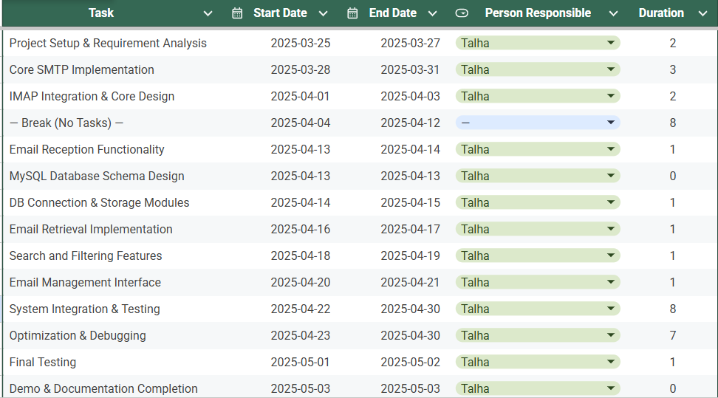
Fig 1. Task Distribution Table
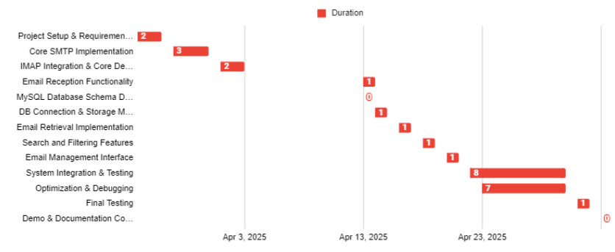Fig 2. Gantt chart (Days)

5. Project Feasibility

Technical Feasibility
The project is technically feasible using Python's built-in libraries and email provider in app passwords:

Email Protocol Implementation:
- Python's smtp for SMTP protocol handling
- Library for asynchronous SMTP server implementation
- Python's imap for IMAP protocol implementation
- Built-in socket functionality (abstracted by SMTP libraries)

Database Components:
- MySQL for reliable email storage
- mysql-connector-python or PyMySQL for database connectivity
- Proper schema design for email attributes

Management Interface:
- Python modules for email retrieval and management
- Mysql workbench/python file for creation of tables.

File Operations:
- os module for file system operations
- File path manipulation for attachments
- Directory creation and file writing for downloads

GUI Framework:
- tkinter for cross-platform user interface
- Threading for responsive UI operations
- Event-driven programming for user interactions

Technical Risks:
- Email protocol edge cases
- Database connectivity issues
- Large email handling capabilities
- Vulnerable to phishing attacks
- In app passwords make your email account vulnerable hence 2FA required
- Concurrent access management

Economic Feasibility
The project requires minimal financial investment:

Development Costs:
- Programming time: Student effort only
- Testing resources: Own Laptop / PC
- Software: All open-source libraries

Resource Requirements:
- Development machines (already available)
- MySQL server (can run locally)
- Testing environment (local network)
- In App password (Mail Provider)

Operational Costs:
- No licensing fees
- Minimal maintenance overhead
- Local database storage only

Schedule Feasibility
The 5-week timeline is realistic given:
- Two team members working efficiently
- Use of established Python libraries (not building from scratch)
- Clear phase-based approach
- Focus on core functionality

Time Constraints:
- 5-week project duration
- Academic workload management
- Testing and documentation time

6. Hardware and Software Requirements

Hardware Requirements:
There are no specific hardware requirements but it's always good to have the following:
- Development Machines: 2 systems with minimum specifications:
- Processor: Intel i5 or equivalent
- RAM: 8GB minimum
- Storage: 10GB free space
- Network: Internet connectivity (MAIN)

Software Requirements:
Python Environment:
- Python 3.8+
- Virtual environment (venv)

Python Libraries:
- smtplib (built-in)
- imaplib (built-in)
- email (built-in)
- mysql-connector-python
- ssl (built-in)
- mimetypes (built-in)
- datetime (built-in)
- json (built-in)
- os (built-in)
- queue(build-in)

Database:
- MySQL 8.0+
- MySQL Workbench

Development Tools:
- Visual Studio Code / PyCharm
- Command line interface

Testing Tools:
- Email client for testing (Gmail/Yahoo/Outlook)
- MySQL CLI/GUI tools
- Network monitoring (optional)

7. Diagrammatic Representation of the Overall System

System Architecture

The architecture type is a Layered Client-Server Architecture with Producer-Consumer Threading Model.
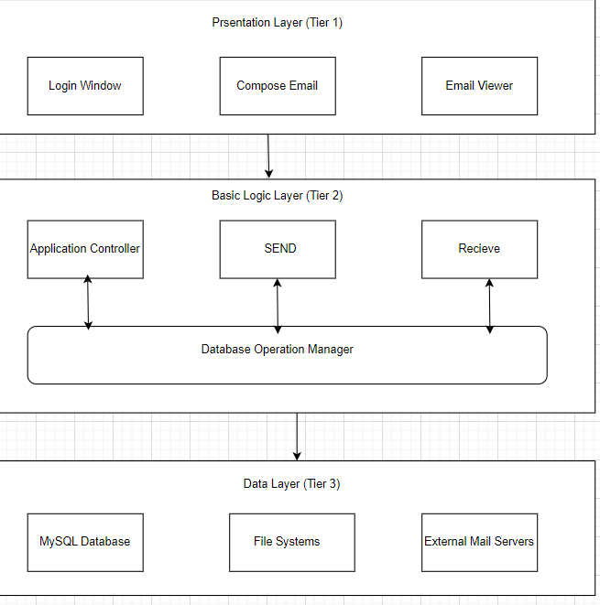
Fig 3. Project Architecture
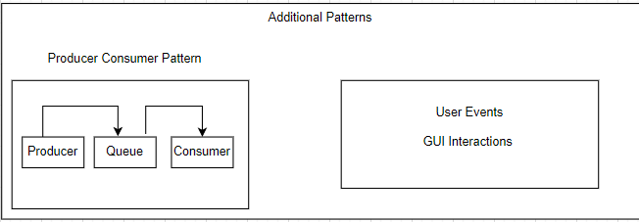
Fig 4. Additional Patterns
Fig 3-4 show the system architecture some features include:
- GUI Layer: Tkinter application interface
- Backend Services: SMTP sending and IMAP receiving modules
- Database Layer: MySQL storage with DatabaseManager
- File System: Organized attachment storage
- Producer Consumer: For handling background tasks efficiently
- Network Protocols: SSL/TLS encryption for secure communication

Database Schema:
The database schema shows different entities with different attributes all of which are related to each other. Some entities include

- users table: Stores user credentials, display names, and provider information
- emails table: Stores email metadata (subject, sender, recipients, date) with user relationship
- attachments table: Stores file information with email relationship and code detection flag
- recipients table: Tracks email recipients with type (to, cc, bcc) and email relationship
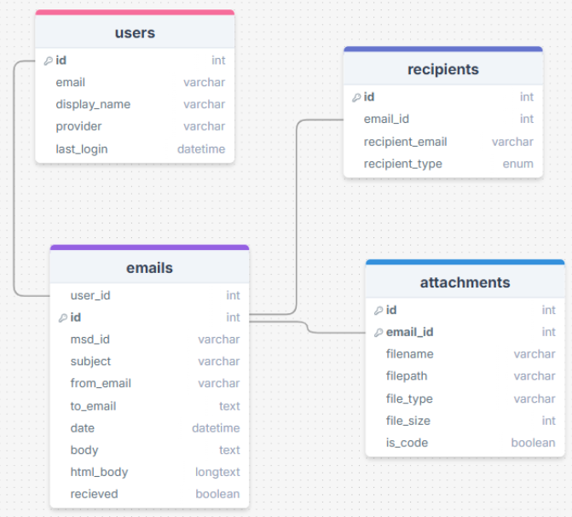
Fig 5. E-R Diagram

SystemFlow Diagram:
Complete email client workflow showing login process, email composition/sending via SMTP, email reception via IMAP, and storage in MySQL database.

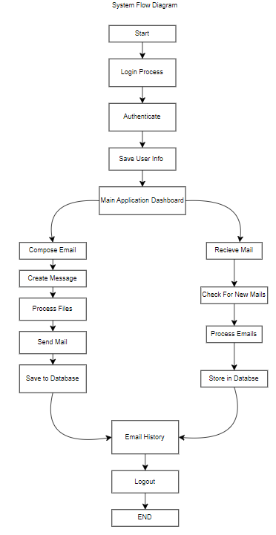
Fig 6. Workflow diagram

8. References
[1] Klensin, J., "Simple Mail Transfer Protocol," RFC 5321, October 2008.
[2] Resnick, P., ed., "Internet Message Format," RFC 5322, October 2008.
[3] Python Software Foundation, "Socket Programming HOWTO," https://docs.python.org/3/howto/sockets.html
[4] PostgreSQL Global Development Group, "PostgreSQL Documentation," https://www.postgresql.org/docs/
[5] FastAPI Documentation, "FastAPI," https://fastapi.tiangolo.com/
[6] SQLAlchemy Documentation, "SQLAlchemy - The Database Toolkit for Python," https://docs.sqlalchemy.org/
[7] RFC 2554, "SMTP Service Extension for Authentication," March 1999.

